**Project Report**

**on**

**Educational AR Book**

in partial fulfilment for the award of the degree of

**BACHELOR OF ENGINEERING**

IN

**BE CSE AIML**

**Submitted by:**

Aditya Srivastava (24BAI70067)

Krrishika Rana (24BAI70109)

Ronit Prashar (24BAI70377)

Krrish Joshi (24BAI70093)

….

**Under the Guidance of**

Dr. Divneet Singh Kapoor

**ACADEMIC UNIT-I**



**Chandigarh University**

**April 2025**

**Index**

|  |  |  |
| --- | --- | --- |
| **S. No.** | **Content** | **Page No.** |
| 1 | Project Overview | 1-2 |
| 2 | Objective and Problem Statement | 3-4 |
| 3 | Proposed Solution & Methodology | 5-7 |
| 4 | Key Findings / Results | 8-9 |
| 5 | Conclusion & Learnings | 10-11 |
| 6 | References | 12 |
| 7 | Appendix (if required) | __ |

## Project Overview

Our project is about creating an **Augmented Reality (AR) book** on the **solar system**, specially designed for children. The aim is to make learning more **interactive, engaging, and fun** by using AR technology. When children scan the pages of the book using a mobile device or tablet, 3D models of planets, moons, and other celestial bodies appear on the screen. These models are animated and often accompanied by **audio explanations, fun facts, and interactive features** that help kids visualize and understand the solar system better than traditional books. This blend of technology and education enhances curiosity and improves retention of knowledge.

- It is important because it combines **education with technology** to make learning more **effective and enjoyable** for children. Traditional textbooks can sometimes be boring or hard to understand, especially when it comes to complex topics like the solar system. By using AR, we bring those topics to life—children can **see 3D planets rotating, orbiting, and interacting**, which helps them **understand concepts visually and intuitively**.

This kind of interactive learning:

* Increases **student engagement and interest**.
* Encourages **curiosity and exploration**.
* Improves **retention and understanding**.
* Supports **different learning styles**, especially for visual and kinesthetic learners.

Overall, it creates a more **immersive and memorable learning experience**, which is especially valuable in early education.

- The idea for this project comes from the growing need to **make education more interactive and student-friendly**, especially for young learners. Traditional methods of teaching, like textbooks and lectures, often fail to capture the **attention and imagination of children**. At the same time, children today are highly familiar with smartphones, tablets, and digital content.

**Augmented Reality (AR)** is a modern technology that overlays digital content—such as 3D models, animations, and sounds—onto the real world through a mobile device. By combining AR with education, we can **transform static content into dynamic experiences**.

The solar system was chosen as the topic because:

* It is a core subject in early science education.
* It involves **spatial and visual concepts** that are hard to grasp through 2D images.
* It naturally excites curiosity about space and science.

By developing an AR book on the solar system, the goal is to bridge the gap between **technology and education**, creating a tool that is both **informative and exciting** for young learners.

## Objective and Problem Statement

The main problem We’re trying to solve is the **lack of engagement and understanding** in traditional learning methods—especially for young children learning complex topics like the solar system.

Here are some key issues the project addresses:

* **Boredom and disinterest** in textbook-based learning.
* Difficulty in **visualizing 3D concepts** like planetary orbits, sizes, and distances using only 2D images.
* Limited interactivity, which makes learning **less memorable** and **less effective**.
* The gap between **modern technology** and how it's being used in **classrooms and educational materials**.

By introducing AR into a children’s educational book, the project makes learning more:

* **Interactive**
* **Visual**
* **Fun and memorable**
* **Effective in building curiosity and understanding**

So, the goal is to **transform passive reading into an active learning experience**, making science more accessible and enjoyable for kids.

The main goals of my project are:

1. **Make Learning Fun and Engaging**  
   – Use AR to create an exciting and interactive way for children to learn about the solar system.
2. **Enhance Understanding Through Visualization**  
   – Help kids **visualize planets, orbits, and space-related concepts** in 3D, making them easier to understand than flat images in a book.
3. **Encourage Curiosity and Exploration**  
   – Spark children’s interest in **space, science, and technology** by making the learning experience immersive and hands-on.
4. **Bridge the Gap Between Education and Technology**  
   – Show how **modern tools like AR** can be effectively used in **education**, especially at the school level.
5. **Create a Kid-Friendly Learning Tool**  
   – Design the book in a way that is **simple, safe, and easy to use**, even for young learners with little technical experience.
6. **Improve Retention and Recall**  
   – Provide visual and interactive content that helps children **remember what they learn more effectively**.

In short, the goal is to **revolutionize the way children learn science**, starting with something as exciting as the solar system!

## Proposed Solution & Methodology

Here's how we planned and executed my AR solar system book project:

**🔹 What We Planned to Do:**

1. **Create an educational book** on the solar system targeted at children.
2. **Integrate Augmented Reality (AR)** into the book to make learning interactive.
3. Include **3D models, animations, voiceovers, and fun facts** to explain each planet and other space elements.
4. Make the content **simple, engaging, and age-appropriate** for school-level students.

**🔹 How We Planned to Do It:**

1. **Content Creation:**
   * Researched accurate and **kid-friendly information** about planets, the sun, moons, and other celestial bodies.
   * Designed each page with a focus on **one topic at a time** (e.g., one planet per page).
2. **AR Development:**
   * Used **BlippAR** (or any AR platform) to create and link **3D models and animations** to specific images or markers in the book.
   * Uploaded 3D models of planets and added animations like **rotation, orbiting, scaling**, etc.
3. **Designing the Book:**
   * Created a colorful, visually attractive layout for the book using tools like Canva, Photoshop, or Illustrator.
   * Placed **AR trigger images** or icons on each page to indicate where the user should scan.
4. **Testing and Optimization:**
   * Tested the book using a smartphone or tablet with the AR app.
   * Made sure the **AR experience was smooth, fast-loading, and accurate** in terms of content and interaction.
5. **Feedback and Improvement:**
   * Collected feedback from children, teachers, and parents.
   * Used that feedback to **improve the visuals, language, and interactivity**.

- **BlippAR**  
– For creating and deploying **Augmented Reality experiences**.  
– Used to link 3D models and animations to book pages via image recognition.

**3D Model Sources** (like Sketchfab, TurboSquid, or prebuilt libraries)  
– To download or use **3D models of planets and the solar system**.

**YouTube**

–For the video for children

FLOWCHART

- START

│

▼

Research & Content Planning

– Gather child-friendly info about the solar system

– Decide on book structure (1 planet per page, etc.)

│

▼

Design Book Pages

– Create colorful, engaging layouts

– Add AR marker images or scan targets

│

▼

Collect or Create 3D Models

– Download or make 3D models of planets and space objects

– Ensure models are optimized for AR

│

▼

Build AR Experience (BlippAR / Blippbuilder)

– Upload images (triggers)

– Attach 3D models, animations, and audio

– Test AR scenes

│

▼

Testing & Debugging

– Scan book pages using mobile app

– Check animations, model scaling, and audio

– Fix bugs or lag issues

│

▼

Final Optimization

– Improve design, performance, and interactivity

– Ensure it's kid-friendly and easy to use

│

▼

Final Book Printing & Deployment

– Print the book with final designs

– Share instructions on how to use the AR feature

│

▼

Project Completed!

## Key Findings / Results

- **The Project Scope:** We're building an augmented reality experience for an educational book on the solar system, which aims to make the learning process interactive and engaging. The use of **BlippAR** indicates we’re focusing on AR as a tool to bring static content to life, potentially allowing readers to visualize celestial bodies, planets, and other components of the solar system in 3D.

• **Learning & Building:** The project is giving us an opportunity to explore both **AR technology** and **interactive learning design**. Like we're trying to develop a seamless user experience where readers can engage with the content beyond just reading.

• **Tech Stack (BlippAR):** Since we're using BlippAR, it suggests we’ve had to familiarize ourself with its tools and capabilities—perhaps learning how to overlay digital content onto real-world images or triggering specific animations when scanning parts of the book.

• **Challenges and Opportunities:** This project likely presents challenges around balancing creativity (designing interactive features) with technicality (coding, ensuring smooth AR interaction). But it also offers opportunities to enhance both our technical skills and understanding of user experience design in educational tech.

- Attach circuit diagrams, project images, snapshots, or sample outputs, if applicable.

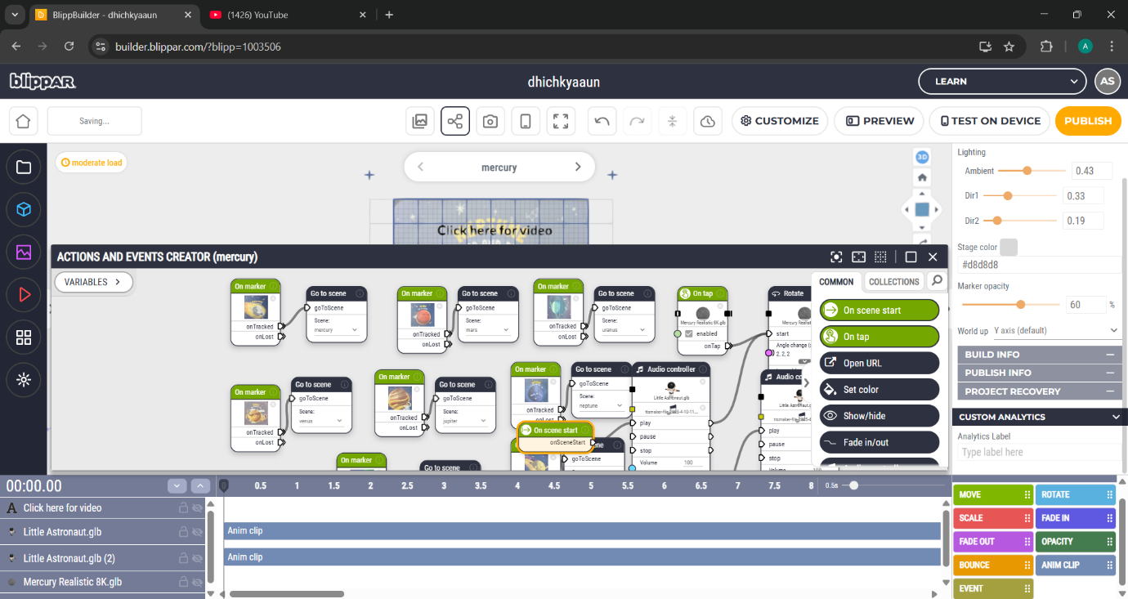

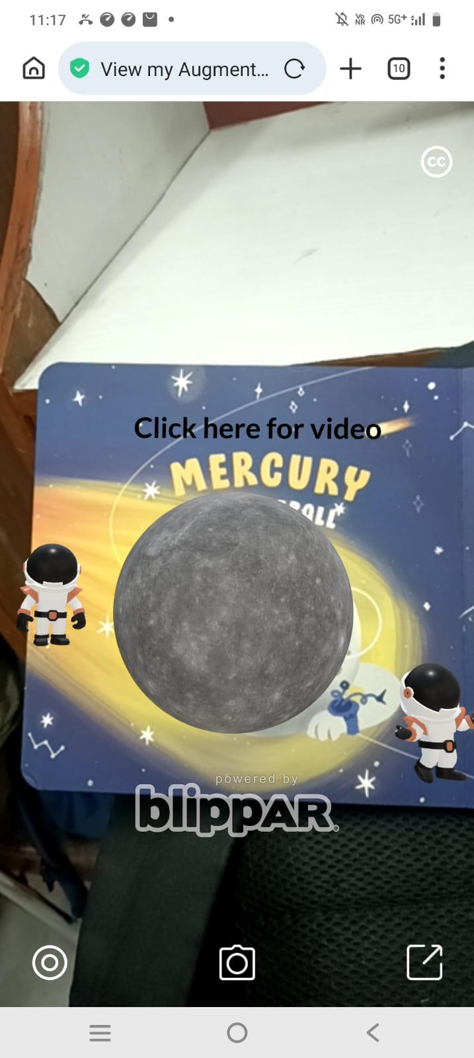

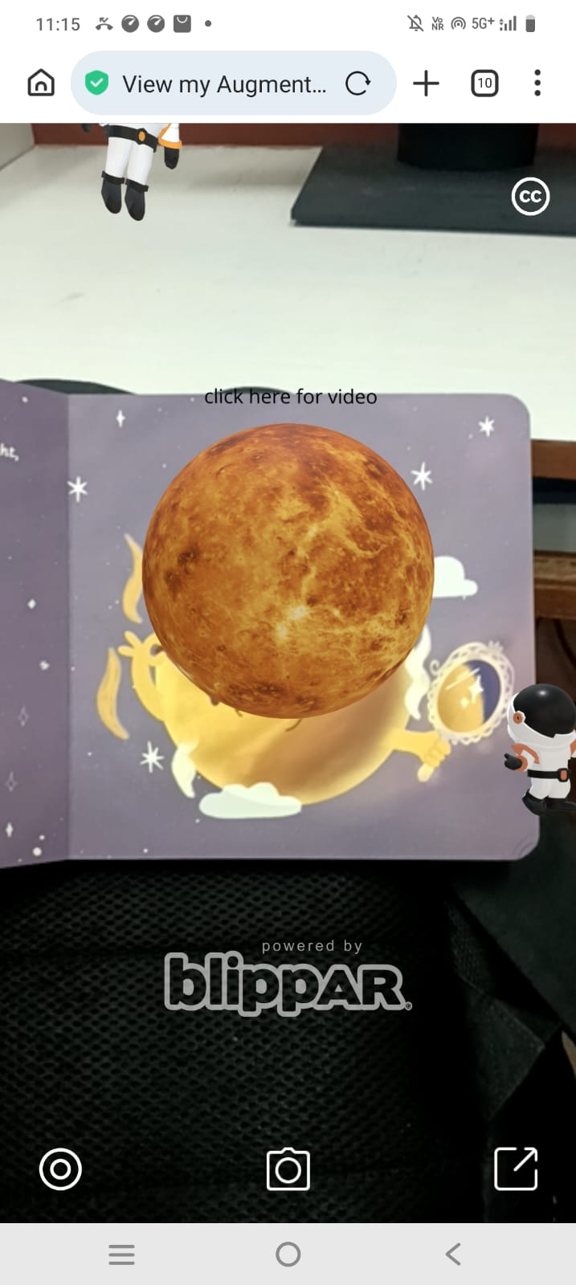

## Conclusion & Learnings

Through this AR solar system book project, you’ve likely gained insights and learned in several key areas:

1. **Augmented Reality Development:**
   * We’ve had hands-on experience with BlippAR, learning how to create interactive and immersive AR experiences. This includes working with **3D models**, **animations**, and **triggering AR content** based on real-world objects.
   * We’ve likely improved your understanding of how AR can be used in education, transforming static information into dynamic, engaging content. This opens up possibilities for future projects and applications in various fields.
2. **User-Centered Design:**
   * By developing an educational tool, we’ve learned to think from the perspective of our **audience**—students or readers. How can AR enhance their understanding of complex concepts like the solar system?
   * The importance of **usability** and **intuitive interfaces** likely became clear to us. We might have had to iterate and test how users interact with the AR content to ensure it’s engaging and easy to use.
3. **Technical Skills:**
   * On the technical side, We’ve built up your knowledge of **coding** for AR, learning how to integrate real-world objects with digital overlays. Depending on our familiarity with coding,
4. **Project Management & Time Management:**
   * Working on such a project, especially in a college setting, may have taught us valuable lessons about **time management** and **task prioritization**—especially if we had to balance it with other coursework. This could help us improve our ability to juggle multiple responsibilities in the future.
5. **Creative Problem-Solving:**
   * There are always challenges when creating something innovative. We probably had to think outside the box to solve problems, such as how to make certain celestial objects appear realistic or how to make the AR content educational yet entertaining.
   * learned how to **debug** and we **iterate** on our work to improve the final experience.

- The improvement which is required or can be done is to make an app so that the user does not require to sanc the QR again

Next step is to make an app an also publish the model in BlippAR

## References

*- •* ***National Geographic Kids*** *–* [*https://kids.nationalgeographic.com*](https://kids.nationalgeographic.com) *– For child-friendly space facts and easy explanations.*

*•* ***BlippAR*** *–* [*https://www.blippar.com*](https://www.blippar.com) *– To learn about AR development and tutorials for using Blippbuilder.*

*•* ***Sketchfab*** *–* [*https://sketchfab.com*](https://sketchfab.com) *– For downloading 3D models of planets and space objects.*

**7. Appendix**

